Supervisor Daily Work Acceptance & Certification Policy

Contents
Supervisor Daily Work Acceptance & Certification Policy 1
1. Purpose 1
2. Principle of Daily Work Acceptance 1
3. Daily Supervisory Responsibility by Work Type 1
4. Daily Operational Certificate: Mandatory First Action of Closure 2
5. Certificate as Operational Insurance 2
6. Clean Daily Certificate Requirement 2
7. Openlink Enterprise Software Systems 3
8. Supervisor Acknowledgement 3
9. Understanding the Daily Certificate Environment (HTML Interface) 3
10. Skill Requirement: Supervisory Literacy and Readiness 5
11. Legislative and Compliance Awareness Expectation 5
12. Policy Expectation When Challenged 6
13. Access Control Mapping – Figure 1 (Generator vs Viewer) 6
13.1 Certificate Generator Access (Create / Submit) 6
13.2 Certificate Viewer Access (Read Only) 7
13.3 Separation of Duties 7
13.4 Access Revocation and Exception Handling 7
14. Final Position 7

1. Purpose
This policy defines the mandatory daily supervisory obligation linked to scheduled work, operational accountability, and the submission of the Supervisor Daily Operational Certificate within the Openlink Enterprise Software Systems. It establishes the standard by which supervision is accepted, executed, and formally certified.
This policy exists to protect: - The client accounts entrusted to the organisation - The organisation’s contractual, operational, and compliance position - The supervisor’s role as the accountable authority for daily delivery

2. Principle of Daily Work Acceptance
Supervision by work means that once a supervisor is scheduled, that supervisor:
- Accepts the work assigned for that day in full;
- Lives the schedule, meaning the supervisor actively operates within the defined time blocks, controls, and checkpoints;
- Honours the work type assigned for that schedule to its fullest extent;
- Ensures completion, not partial progress, every time they are on duty.
Being on schedule is a formal acceptance of responsibility for the work type, the team, the outputs, and the account obligations linked to that day.
There is no concept of passive supervision.

3. Daily Supervisory Responsibility by Work Type
For every scheduled day, the supervisor commits to the following:
- Executing all supervisory controls relevant to the assigned work type;
- Managing and enforcing the team schedule for that work;
- Ensuring all required meetings, outputs, reviews, and interventions occur as planned;
- Addressing blockers, deviations, or risks immediately;
- Confirming that all work completed aligns with contractual, operational, and compliance requirements.
If a supervisor is scheduled, the expectation is full execution of the role for that day.

4. Daily Operational Certificate: Mandatory First Action of Closure
The uploading of the Supervisor Daily Operational Certificate is not optional.
It is the first and only accepted action of daily closure once all daily requirements have been completed.
The certificate confirms that: - Every item on the daily checklist has been executed; - All outputs have been reviewed and signed off; - All compliance requirements have been met; - The day’s work is complete and formally closed.
No workday is considered fulfilled until the certificate has been completed and uploaded.

5. Certificate as Operational Insurance
The daily certificate serves as operational insurance for:
- The organisation’s responsibility toward client accounts;
- The supervisor’s accountability for the day’s delivery;
- The integrity of work performed by the team;
- Protection against disputes, rework, or compliance challenges.
Each certificate is a formal record that the organisation has exercised due care, oversight, and control over the accounts served on that day.

6. Clean Daily Certificate Requirement
Supervisors must understand and accept the importance of a clean daily certificate.
A clean certificate means: - All checklist items are confirmed truthfully; - There are no outstanding actions, unresolved blockers, or unreviewed items; - All supporting records align with the declared outputs; - The certificate can withstand audit, client review, and internal verification.
A certificate that does not reflect reality undermines the organisation’s responsibility to its clients and will be treated as a serious breach of duty.

7. Openlink Enterprise Software Systems
All Supervisor Daily Operational Certificates must be:
- Uploaded to the Openlink Enterprise Software Systems;
- Stored as part of the permanent operational record;
- Available for verification, review, and analysis.
Openlink serves as the single source of truth to: - Verify that daily supervision occurred; - Understand what was delivered, reviewed, and closed; - Demonstrate compliance, accountability, and consistency over time.

8. Supervisor Acknowledgement
By accepting a supervisory schedule, the supervisor acknowledges that:
- They understand this policy;
- They accept full responsibility for the work assigned for that day;
- They commit to completing and uploading a clean daily certificate every time they are on schedule;
- They recognise the certificate as a critical control protecting the accounts, the organisation, and themselves.
Supervision is not defined by presence, but by verified daily closure.

9. Understanding the Daily Certificate Environment (HTML Interface)
Below is the Supervisor Daily Operational Certificate interface used to generate the official daily record:
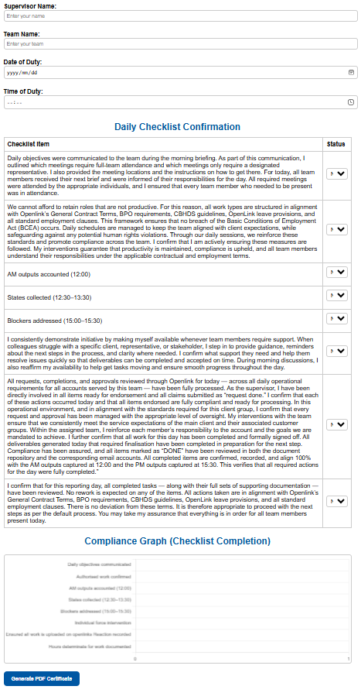
Figure 1: Supervisor Daily Operational Certificate Generator (HTML Environment)
The person performing this supervisory work type for their team must be an authorised supervisor, must have access to the Certificate Generator, and must have been fully trained to operate it. This responsibility is non-delegable and carries full accountability for daily operational closure, compliance, and protection of the accounts served.
This interface is not a form for data capture only. It is a control surface that reflects supervisory competence, accountability, and legal awareness.
When a supervisor looks at this screen, they must understand that:
- Every metadata field (Supervisor Name, Team Name, Date, Time) establishes personal accountability;
- Every checklist statement is a formal declaration, not a tick-box exercise;
- Every confirmation is capable of being reviewed, audited, or questioned;
- The generated PDF is a binding operational record.

10. Skill Requirement: Supervisory Literacy and Readiness
Supervisors operating this certificate environment are required to be skilled enough to stand behind what they confirm.
This includes the ability to:
- Explain what each checklist item means in practical operational terms;
- Justify supervisory decisions when questioned by management, clients, or auditors;
- Demonstrate understanding of why time-based controls (12:00, 15:30, etc.) exist;
- Defend the accuracy of the certificate with supporting records if required.
This role requires active understanding, not mechanical completion.

11. Legislative and Compliance Awareness Expectation
Supervisors must be able to respond, at a practical level, to legislative and compliance-related questions connected to their daily certificate.
This includes basic working knowledge of:
- The Basic Conditions of Employment Act (BCEA);
- Contractual work definitions and authorised work types;
- Human rights and fair labour practice principles;
- Client and BPO compliance expectations;
- Internal Openlink General Contract Terms and CBHDS guidelines.
Supervisors are not expected to be lawyers, but they are expected to understand and apply the rules that govern the work they certify.

12. Policy Expectation When Challenged
If a supervisor is asked: - Why was this work authorised? - How were hours determined? - Why is this certificate clean? - What controls were applied today?
The supervisor must be able to answer confidently, factually, and consistently with what is declared in the certificate.
Failure to understand or defend the certificate undermines the integrity of supervision and will be treated as a capability or compliance concern.

13. Access Control Mapping – Figure 1 (Generator vs Viewer)
Figure 1: Supervisor Daily Operational Certificate Generator is directly governed by access control rules within the Openlink Enterprise Software Systems.
The system distinguishes clearly between who may generate certificates and who may view certificates.

13.1 Certificate Generator Access (Create / Submit)
Access to generate and submit a Supervisor Daily Operational Certificate is restricted to individuals who meet all of the following conditions:
- Are formally appointed to the Supervisor role for the relevant team;
- Are scheduled on duty for the reporting day;
- Have completed approved supervisory training, including:
  - Operational controls and daily work standards;
  - Labour and compliance awareness (BCEA, authorised work, fair practice);
  - Use of the HTML Certificate Generator;
- Have been explicitly authorised in Openlink to perform this work type;
- Accept full, non-delegable accountability for the certificate submitted.
Only users meeting these conditions may: - Access the generator interface; - Confirm checklist items; - Generate and upload the official PDF certificate.
Generator access cannot be shared, delegated, or substituted.

13.2 Certificate Viewer Access (Read Only)
Viewer access is granted to authorised stakeholders for oversight and assurance purposes.
Users with viewer access may: - View submitted certificates; - Download copies for review or audit; - Reference certificates for performance, compliance, or client assurance.
Viewer access does not permit: - Editing or regenerating certificates; - Changing checklist confirmations; - Submitting certificates on behalf of a supervisor.
Viewer roles may include: - Operations management; - Compliance and audit functions; - Client assurance representatives; - Finance or billing reviewers (where applicable).

13.3 Separation of Duties
The separation between Generator and Viewer access is a mandatory internal control.
This separation ensures: - No self-review or retrospective alteration of records; - Integrity of the daily operational record; - Clear accountability for daily closure decisions.
Any breach of this separation is treated as a governance and compliance violation.

13.4 Access Revocation and Exception Handling
Generator access may be suspended or revoked where: - Required training lapses or expires; - Supervisory authority is withdrawn; - Certificates are found to be inaccurate, incomplete, or misleading; - Compliance or capability concerns are identified.
Exceptions to these rules require formal approval and must be documented within Openlink.

14. Final Position
The Certificate Generator shown in Figure 1 is a controlled operational authority, not a general system feature.
Access to generate certificates signifies trust, competence, and accountability.
Supervisors granted this access are expected to: - Use it responsibly; - Defend every declaration; - Protect the integrity of the accounts and the organisation.
The certificate is not completed because the system allows it.
It is completed because the supervisor is authorised, trained, and prepared to stand behind it.

